**Overview**

This report provides contextual ecosystem information for summer flounder on the NE Shelf. Data extractions for spring and fall are confined to the areas representing the stock definition based on respective survey strata sets. The information is intended to span a range of potential factors affecting this species, which can be taken up to qualitatively inform the interpretation of population status and/or quantitatively to provide data to improve model fits and response to ecosystem factors. The range and complexity of ecosystem data makes it unlikely to find the most relevant and comprehensive factor variables with a first evaluation; this process will require an iterative approach of evaluation and feedback.

The graphs in this report (example below) provide a visual indication of time series trend with a linear regression fit (red line) and a Mann Kendell trend test where test p value is in the main title. The time series is first evaluated for autocorrelation (EnvStats R package, version 2.3.1) and if significant autocorrelation is found in the data, the Mann Kendall test is done on pre-whitened data (zyp R package, version 0.10-1) following Yue et al. (Yue *et al.* 2002). In addition, change points or potential regime shifts were identified using the sequential averaging algorithm called STARS or “sequential *t*-test analysis of regime shifts” (Rodionov 2004; Rodionov 2006) which finds the change-points in a time series. The STARS algorithm parameters were specified *a priori* reflecting the default setting of the procedure used to detect decadal scale change. The alpha level, which is used to test for a change in the mean, was set to α = 0.1. The length criteria, the number of time steps used when calculating the mean level of a new regime, was set to 10. The Huber weight parameter, which determines the relative weighting of outliers in the calculation of the regime mean, was set to 1. Change points at the very beginning or end of the time series may not be estimated reliably and require further observations to confirm their stability.

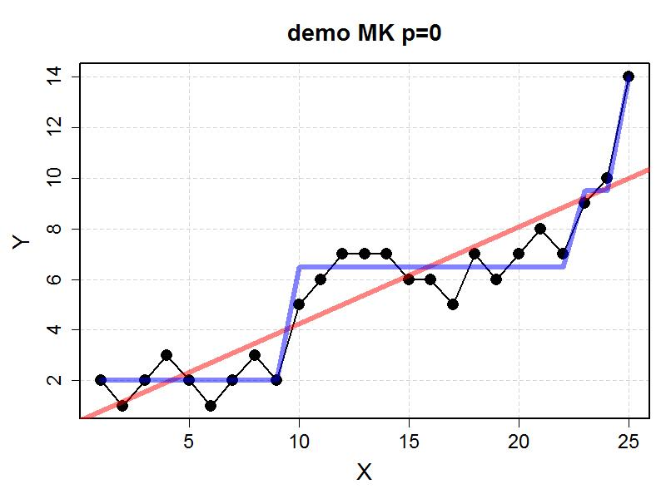

**Optimally Interpolated Temperature from NEFSC Ecosystem and Resources Surveys**

An optimal interpolation procedure was used to estimate NE Shelf surface and bottom temperatures for two seasonal time frames (see methods). The temperature estimates were standardized to April 3 and October 11 for spring and fall, respectively. Spring surface and bottom temperatures within the spring summer flounder stock area have trends with positive slopes (upper and lower left figures, respectively); however, neither time series trend was significant. There are no change points or regime shifts in the spring BT time series, but there is a change point in the surface temperature in 1982. Fall surface and bottom temperatures within the fall summer flounder stock area have trends with positive slopes (upper and lower right figures, respectively); in both cases, the time series trends were significant. Change points were identified in the fall surface temperature in 1997 and 2011, noting that the 2011 change was of greater magnitude at approximately 1°C.

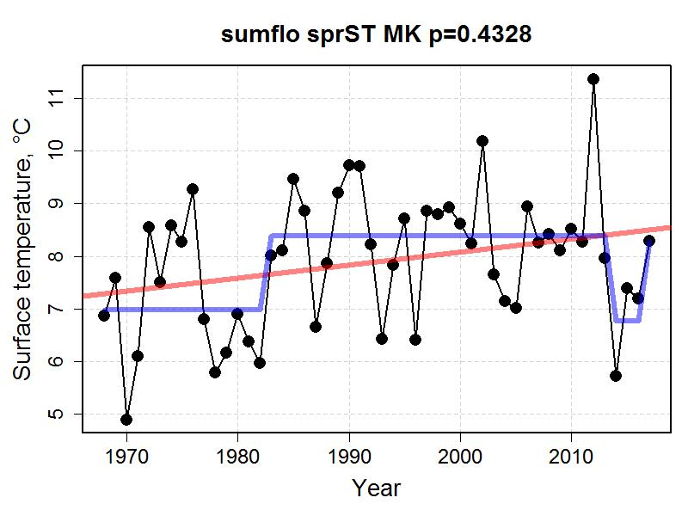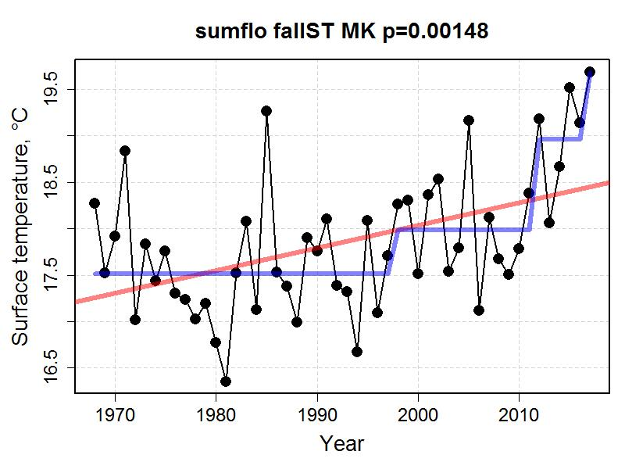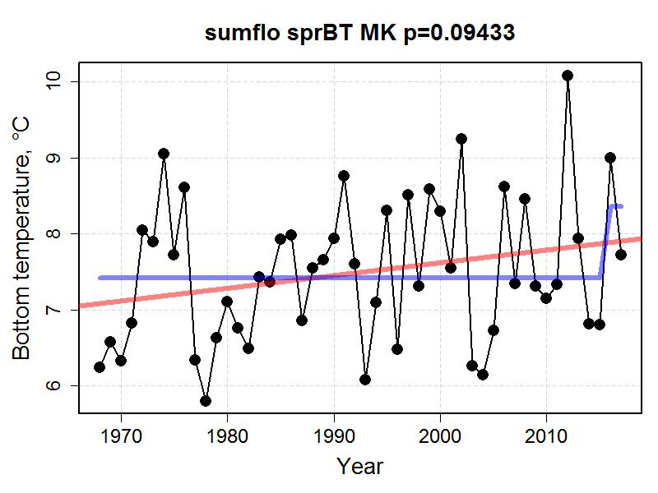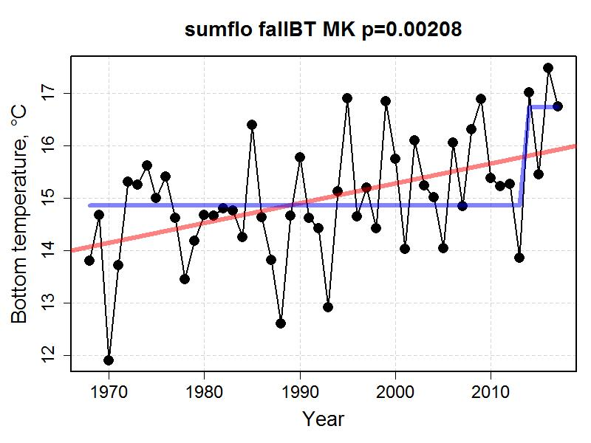

**Optimally Interpolated Salinity from NEFSC Ecosystem and Resources Surveys**

An optimal interpolation procedure was used to estimate NE Shelf surface and bottom salinity for two seasonal time frames (see methods). Though collected with temperature data, reliable instrumentation limits this time series to 1992-2017. The salinity estimates were standardized to April 3 and October 11 for spring and fall, respectively. Spring surface and bottom salinity within the spring summer flounder stock area have significant positive trends (upper and lower left figures, respectively); there are change points or regime shifts in both time series in 2012. Fall surface and bottom salinity within the fall summer flounder stock area have positive trends, but only the surface trend is significant (upper and lower right figures, respectively). Like the spring time series, both fall time series had change points, but the fall changes point were in 2011.

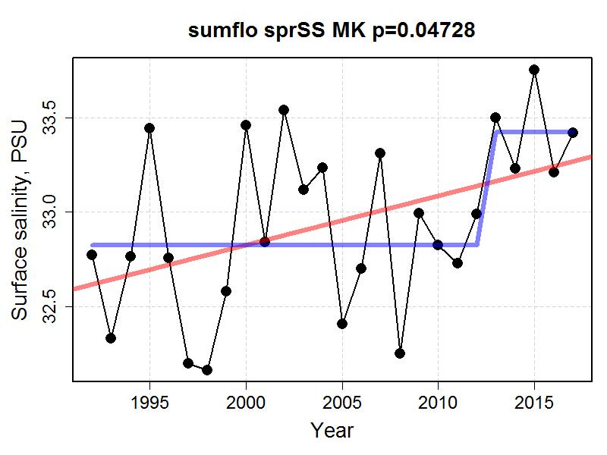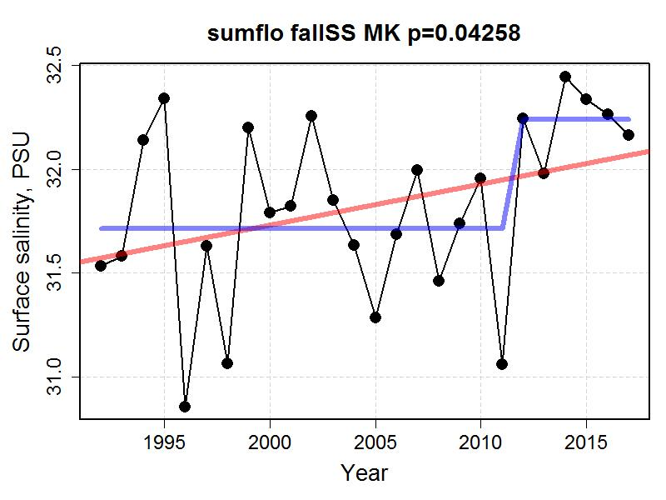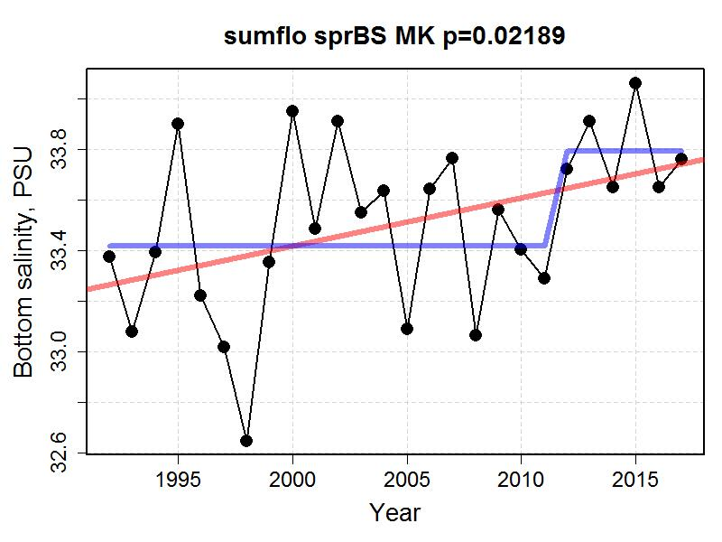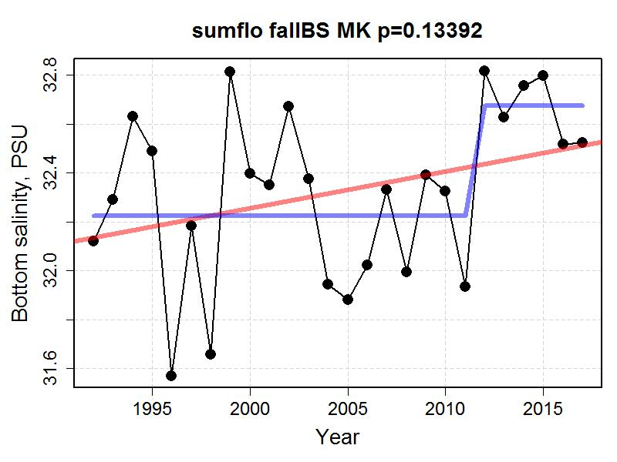

**Chlorophyll Concentration**

The concentration of chlorophyll was measured with a suite of satellite sensors and merged into a single dataset (see methods). Chlorophyll concentrations in the spring summer flounder stock area was without any discernable trend or a reliably estimated change point (left figure). Fall chlorophyll appears to be decreasing and the trend statistic was significant (right figure). A change point appears to have occurred in the fall data in 2011.

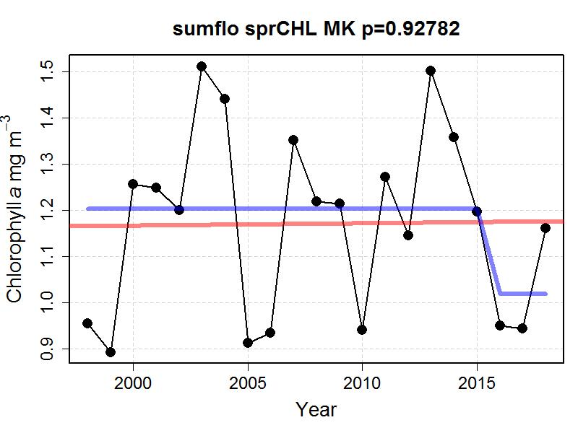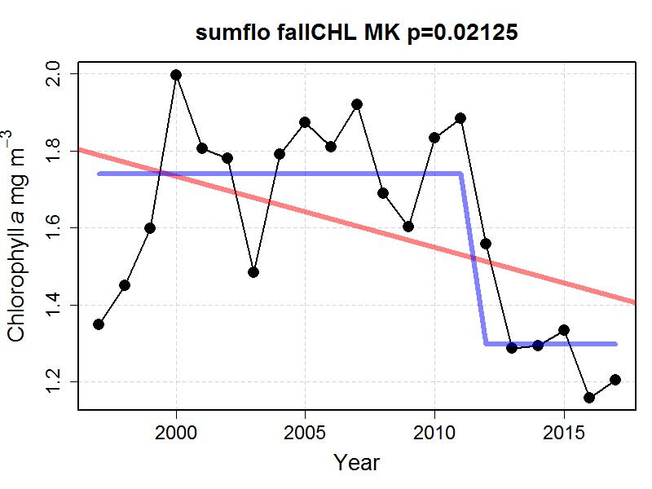

**Zooplankton abundance**

The main species of zooplankton identified in the diet of summer flounder larvae are *Centropages typicus* (CTYP), *Temora longicornis* (TLONG), *and Pseudocalanus spp.* (PSEUDO) (Grover 1998). The abundance of these taxa with the respective seasonal stock areas for spring and fall are shown below. This depiction of zooplankton abundance utilizes spatial smoothing (see methods). During spring, *C. typicus* and *T. longicornis* were characterized by increasing trends whereas *Pseudocalanus* had a declining trend (see plots on left). The trends for *C. typicus* and *Pseudocalanus* were significant. The change point analysis for the spring zooplankton abundance suggests *C. typicus* and *T. longicornis* had a period of elevated abundance starting in the late 1980s and lasting until the early 2000s. It should be noted that the report from Grover would reflect the importance of *Pseudocalanus* just it started to decline around the year 2000. It is assumed that the spring abundances of these taxa would be most relevant to the growth and survival of larval summer flounder. The fall abundance of all three taxa have significantly declined, which may have ramifications related to the growth and condition of new recruits to the population (see plots in right).

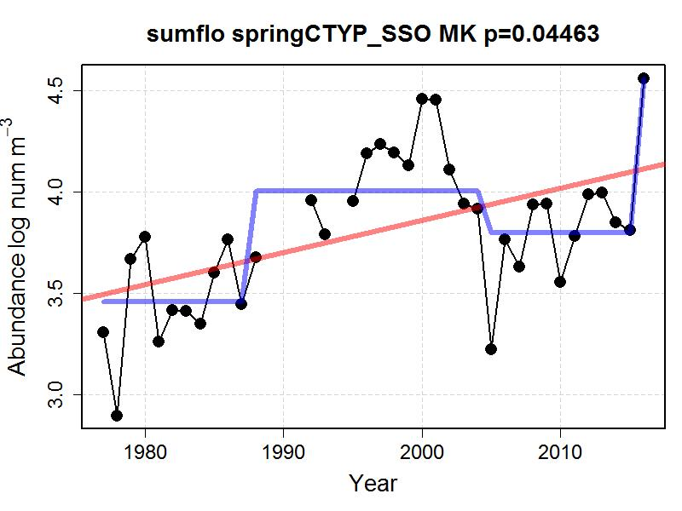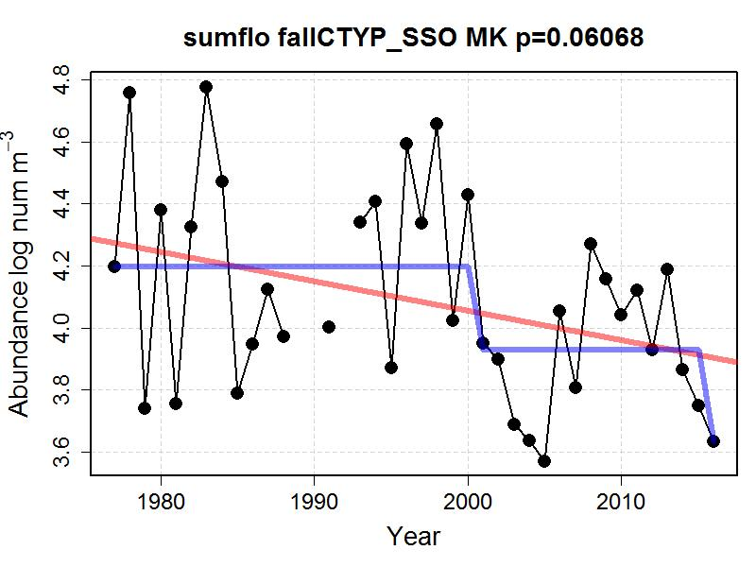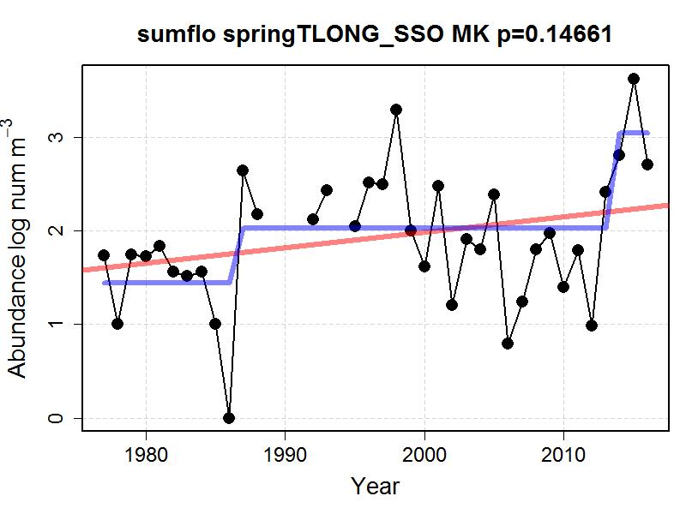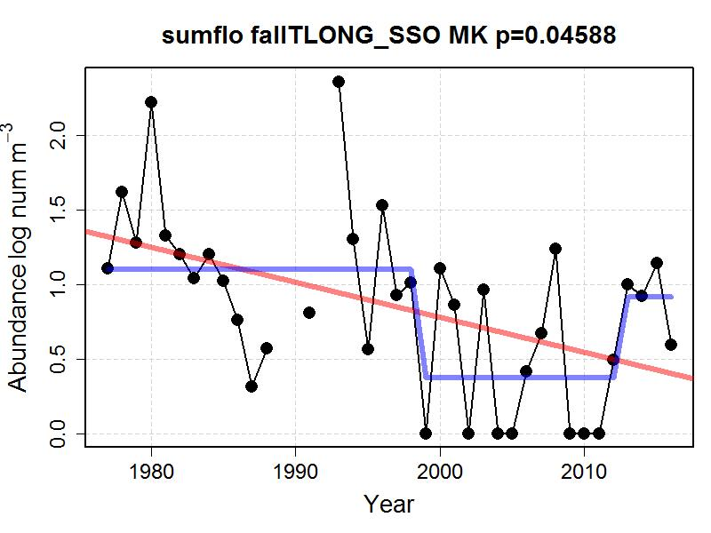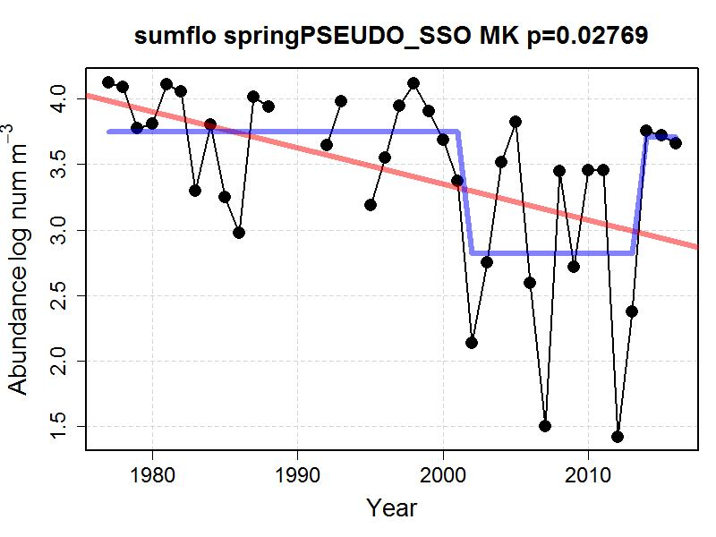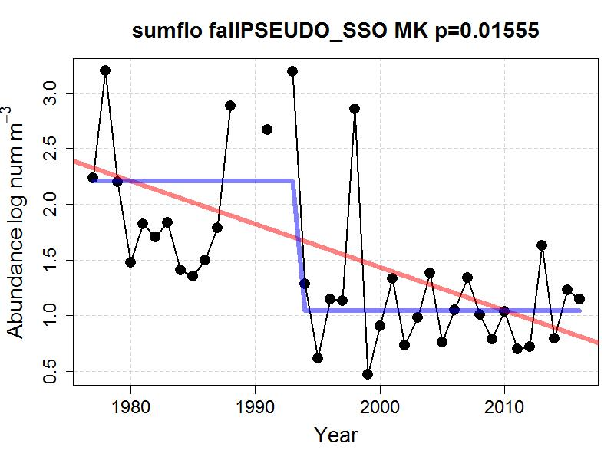

**Probability of Occurrence and Habitat Area from Species Distribution Models**

The occupancy probability for summer flounder based on classification random forest models were extracted for the spring and fall stock definition areas (see methods). The occupancy probability has increased in both stock areas (see top plots). The area of the Northeast Shelf with an estimated occurrence probability of 0.5 or greater has increased in both seasons. In spring, the occupancy area have increased from approximately 50,000 km2to 80,000 km2, noting a decrease in 2017 (lower left plot). The fall habitat has increased from approximately 40,000 km2to 60,000 km2with no indication of the trend abating (lower right plot).

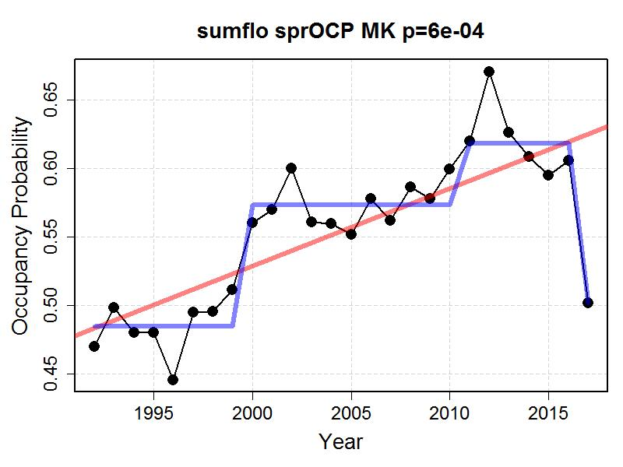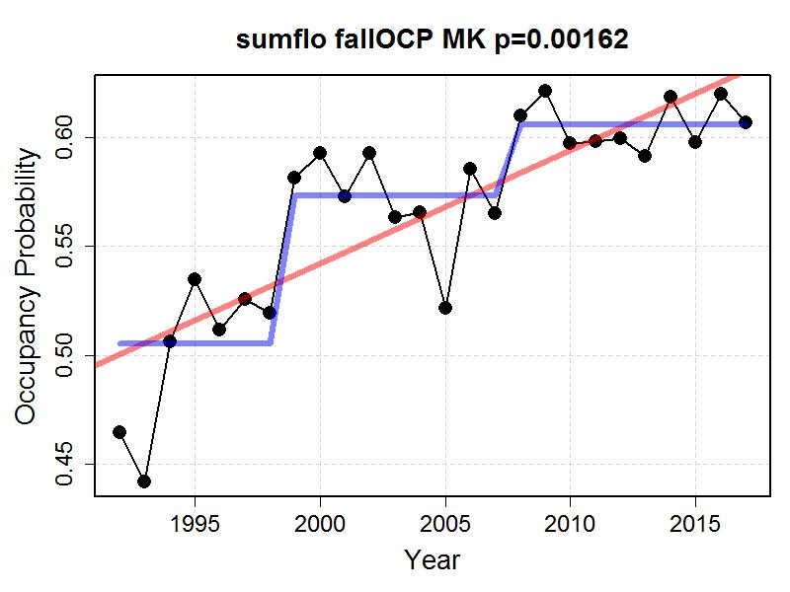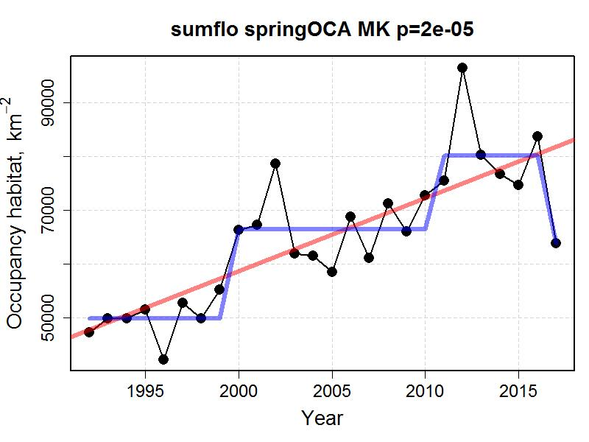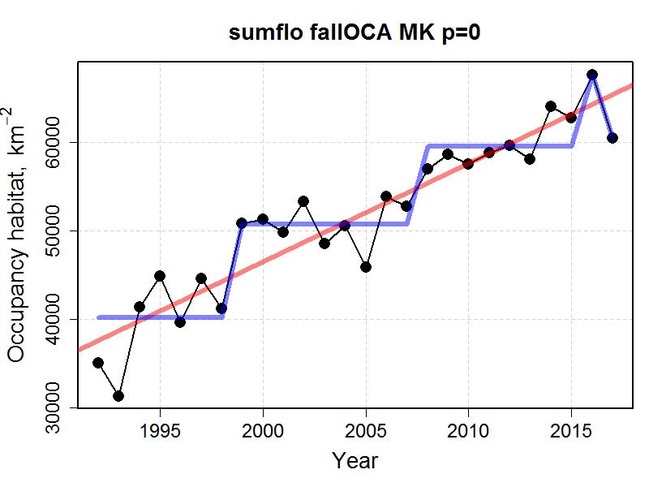

**Methods – Surface and Bottom Temperature and Salinity**

**Study System**

This method deals with the surface and bottom thermal environments of the U.S. Northeast Shelf ecosystem, which roughly aligns with the boundaries of the Northeast U.S. Continental Shelf large marine ecosystem (LME). Surface and bottom temperature was estimated over a 0.1° latitude/longitude grid, termed the estimation grid, which circumscribes the range of ecosystem assessment areas in the region (Figure 1). The difference between the extents of the estimation grid from the extent of the LME relate to the resource management programs that are the sources of the data, which are focused on fishery management needs in the region.

**Data Source**

Temperature and salinity were collected on the Northeast Shelf as part of ongoing resource and ecosystem surveys conducted by the Northeast Fisheries Science Center. Water column temperatures have been collected contemporaneously to trawl tows associated with a bottom trawl survey beginning in the fall of 1963 and five years later during spring (Desprespatanjo, Azarovitz & Byrne 1988). In addition, the ecosystem has been surveyed within the context of multiple sampling programs with varying sampling designs. The two most comprehensive monitoring programs over the study period were the MARMAP (1977-1987) and the Ecosystem Monitoring Program or EcoMon (1992-present) programs, both serving as shelf-wide surveys of the ecosystem (Sherman *et al.* 1998; Kane 2007). Temperature measurements were made with a mix of Conductivity Temperature and Depth (CTD) instruments, analog XBT, digital XBT, mechanical BT, glass thermometers (bottle temps) and trawl mounted temperature loggers instruments collecting either water column profiles or temperatures measured at targeted depths. Salinity measurements used in this analysis was limited to 1992-2017 when CTD instrument were used. Surface and bottom temperatures were identified from these measurements. Temperatures representing the spring period were drawn from data collected during the months of February to June; however, 99% of the samples were collected during the months of March to May. Likewise, the fall period samples were drawn from data collected during September to December, with 99% of the samples collected during September to November. The total number of surface temperature measurements were 14,540 and 14,666 for spring and fall, respectively; and, 14,450 and 14,656 for spring and fall bottom temperature, respectively. On average, there were 290 temperature measurements by season, depth, and year. The number of salinity observation per year were similar.

**Interpolation Procedure**

We sought to estimate seasonal surface and bottom temperature fields using an optimal interpolation approach. The optimal interpolation was a combination of a climatological depiction of temperature and an annual estimate based on the data for a particular depth and season. There were a number of precursor steps that we will review in sequence. Though the surveys used to collect the data were conducted during the same period each year, there was variation in survey timing. To account for this, temperatures were standardized to a collection date of April 3 for spring surveys and October 11 for fall using linear regression for each depth and season over the sample grid (see Appendix A, Figure A1). For each depth and season, annual shelf-wide mean temperatures were calculated using the data from sample grid locations with at least 80% of the time series present. The annual observations were then transformed to anomalies by subtracting the appropriate annual mean. All the anomalies for a season and depth were combined over years into a single anomaly field or climatology.

The annual estimate of temperature for a depth and season was imputed by used universal kriging to estimate the temperature over the estimation grid with depth as a covariate. The kriging yielded the temperature estimates and a variance estimate over the same grid. The optimal interpolation field was assembled by combining the annual estimate and information from the anomaly climatology. The climatology was re-leveled from anomaly values to temperatures by adding back the appropriate annual mean. For each location in the estimation grid, temperature was calculated as a weighted mean between the kriged annual estimate and the releveled climatology. The weightings in the calculations were partitioned based on the variance field of the annual kriging. The field was divided into quartiles from low to high variance with the weighting ratio of annual:climatology temperatures of 4:1, 3:1, 2:1, and 1:1, respectively. Hence, in areas of low variance the weighted mean was based on a weighting of 4:1, which would reflect a higher contribution of information from the annual estimate and thus be closer to an observation. In areas with high variance, the weighting ratio of 1:1 would reflect a greater effect of the climatology in determining the interpolation estimate.

The optimal interpolation temperature fields were evaluated using cross validation and a comparison to external data. The performance of optimal interpolation was compared to the predictive skill of using either the climatology or annual interpolation alone by doing ten random cross validations of each treatment. Each random draw of training and test sets sampled 3% of the data for the test set, or about 500 observations per draw. The temperature fields were fit with the training data and compared with the test set data. The lowest error rates were realized with the optimal interpolation contrasted with highest predictive error associated with fields based on the climatology alone (see Appendix B, Figure B1). The spatial distribution of error had distinct depth and seasonal patterns. The spatial errors associated with the surface estimates were generally low with the exception of a few locations along the shelf break between latitudes 39-41°N; the spatial error in the bottom temperature varied by season, and was concentrated along the shelf break in spring and across the shelf between latitudes 36-40°N in fall (see Appendix b, Figure B2). The optimal interpolation data were also compared to external data from other collection programs. The absolute errors between surface temperature data collected by satellites and the interpolation had interquartile ranges of approximately ±0.75°C (see Appendix C). The absolute error in a comparison of interpolated bottom temperature to opportunist sampling was approximately ±0.75°C for spring bottom temperature and approximately 0.75-1.0°C in the fall.

Salinity was estimated in the same way with the exception of collection correction, which was deemed unnecessary for the salinity data.

**Figure 1.** Map of the study system with half-degree sample grid (blue lines) and extent of estimation grid shown in beige points (a). Major features of the study system with shelf break marked in purple line (b). 100m depth shown as dashed line.

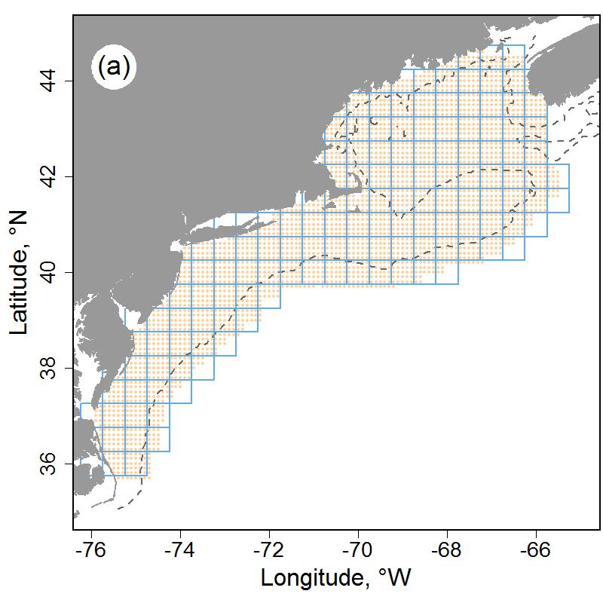

**Appendix A. Date of collection correction.**

The dates of survey data collection varied by year, to date correct temperature measurements, regressions were estimated between temperature and day of the year over the sample grid (0.5° grid) by season and depth. Spring data were transformed to a temperature representing April 3 and fall to October 11 based on the slope estimates shown in the maps in Figure A1.

Figure A1. Spring (a) and fall (b) linear slope coefficients used to date correct surface temperature to standard spring and fall dates; same for spring (c) and fall (d) bottom temperature correction.

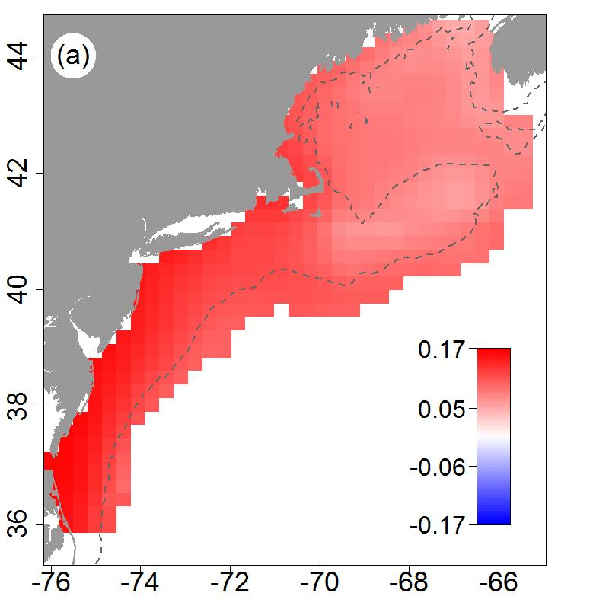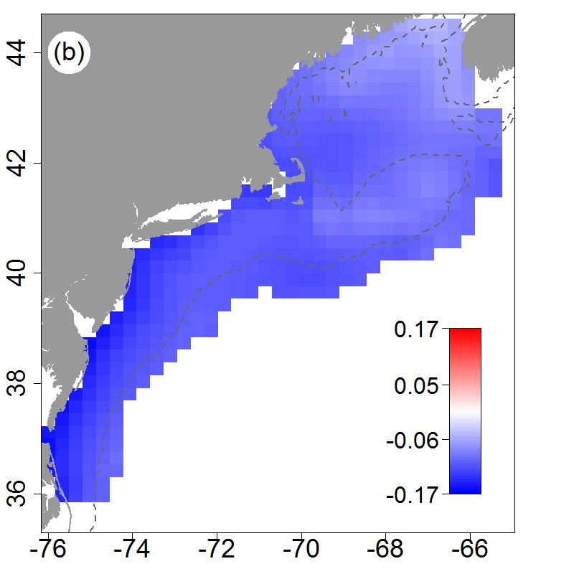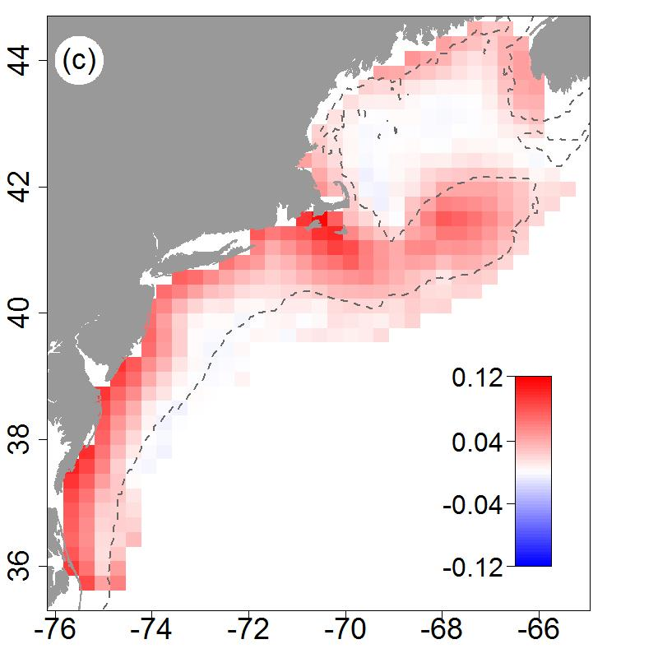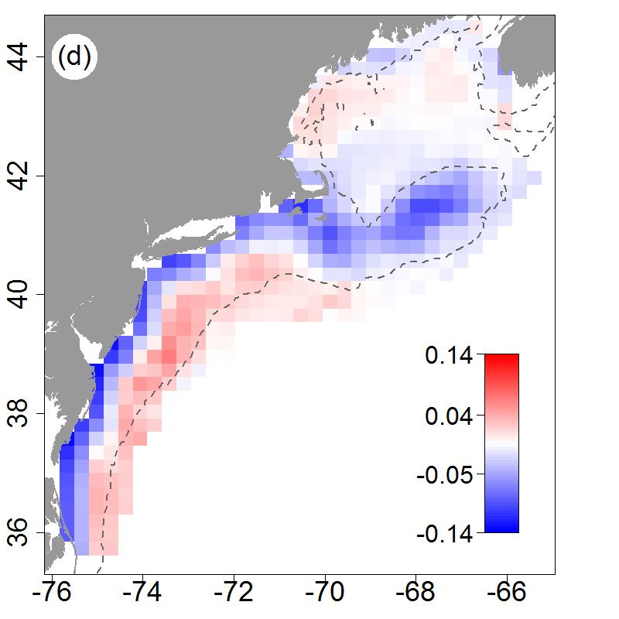

**Appendix B. Cross validation performance of temperature interpolation.**

A series of random draws of training and test sets were taken to evaluate the predictive skill of the estimation procedure. A set of climatology, annual interpolation, or optimal interpolation fields were estimated using the training set and compared to the held-out test set.

Figure B1. Mean and 95% confidence intervals of squared errors for spring (a) and fall (b) surface temperature estimates based on climatology, annual interpolation, and optimal interpolation (OI); same data for spring (c) and fall (d) bottom temperature estimates.



The distribution of errors from the optimal interpolation test sets were evaluated spatially to determine where the larger errors occurred and what ecosystem features they are associated with.

Figure B2. Mean absolute error by 0.1 degree latitude and longitude intervals for spring (a) and fall (b) surface temperature; same data for spring (c) and fall (d) bottom temperature. Red indicates a positive error where blue indicates negative.

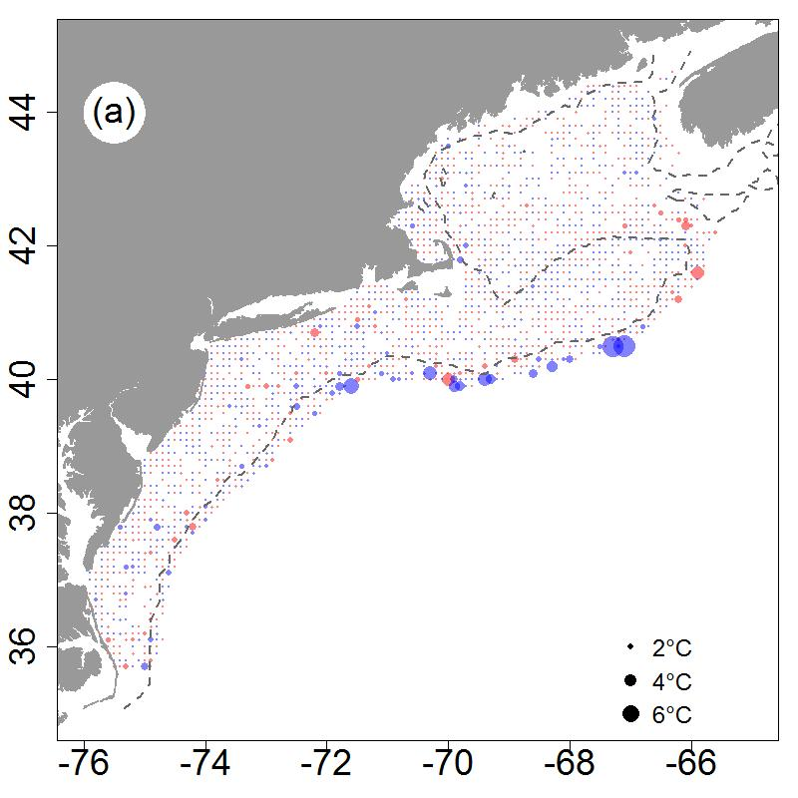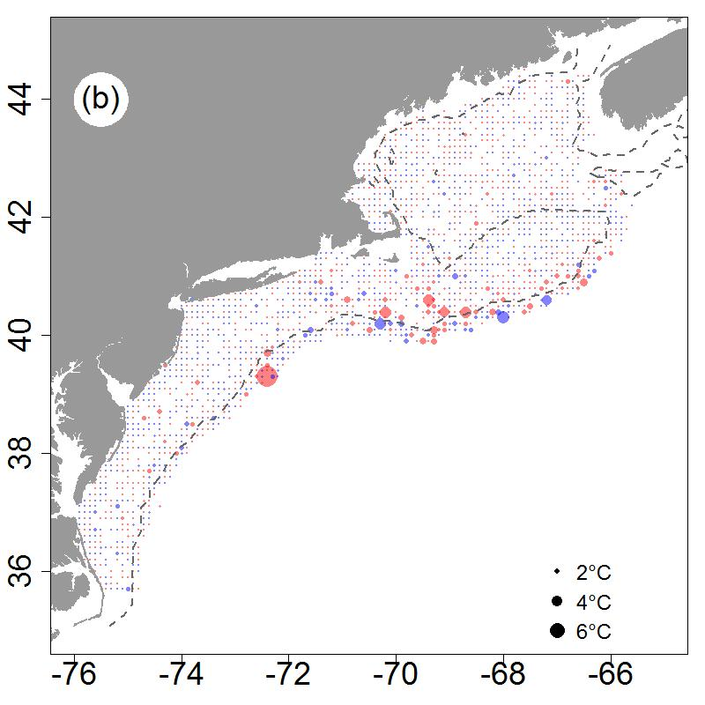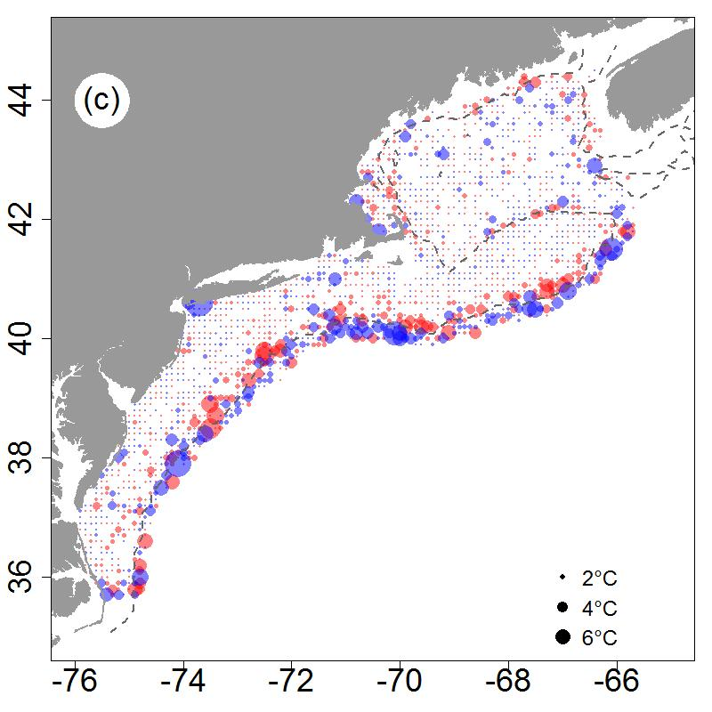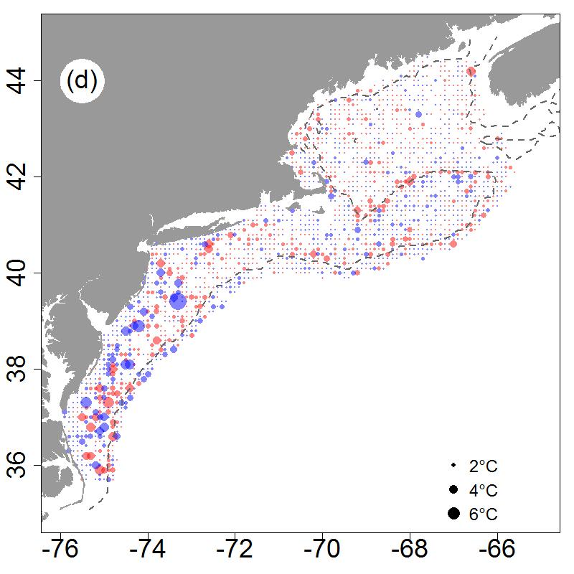

**Appendix C. Comparisons to external data sources.**

Sea surface temperature estimated in this study were compared to the OISST dataset (<https://www.ncdc.noaa.gov/oisst>) serving as a source of data for external comparison. The OISST data for April 3 (spring) and October 11 (fall) over the period 1982-2017 were extracted on the same 0.5° grid used in the study. Time series of matching spring and fall temperatures were differenced (external minus interpolation data) and presented in the figure below (sample size for surface spring and fall data were 5220 and 5365, respectively). The interquartile range for the surface comparisons were generally symmetric around zero with differences between 0.5-1°C. Bottom temperature estimated in this study were compared to the data from a cooperative data collection program for external comparison. The “Environmental Monitors on Lobster Traps” is a cooperative research program that collects bottom temperatures (data available from <http://comet.nefsc.noaa.gov/erddap/tabledap/eMOLT.html>). The data for spring and fall were extracted from rasters of the study data to match the extremal data. The extremal data covered the period 1968-2017, with 360 data points for the spring and 728 for the fall. Spring bottom comparisons yielded the smallest interquartile range of differences less than 0.5°C, where fall comparisons were slightly larger and biased to lower interpolation estimates compared to the external data.

Figure C1. Box plots (box: interquartile range, whisker: 5-95% range, square symbol: mean, line: median) of the difference between external and interpolation data.



**Methods - Chlorophyll data**

Chlorophyll *a* concentration ([Chl]) data extracted from remote-sensing databases based on measurements made with the Sea-viewing Wide Field of View Sensor (SeaWiFS), Moderate Resolution Imaging Spectroradiometer on the Aqua satellite (MODIS), Medium Resolution Imaging Spectrometer (MERIS), and Visible and Infrared Imaging/Radiometer Suite (VIIRS) sensors. We used the Garver, Siegel, Maritorena Model (GSM) merged data product at 100 km (equivalent to a 1° grid) and 8-day spatial and temporal resolutions, respectively, obtained from the Hermes GlobColour website (hermes.acri.fr/index.php). These four sensors provide an overlapping time series of [Chl] during the period 1997 to 2018 and were combined based on a bio-optical model inversion algorithm (Maritorena *et al.* 2010).

**Methods - Zooplankton abundance**

Zooplankton abundance is measured by the Ecosystem Monitoring Program (EcoMon), which conducts shelf-wide bimonthly surveys of the NES ecosystem (Kane 2007). Zooplankton and ichthyoplankton are collected throughout the water column to a maximum depth of 200 m using paired 61-cm Bongo samplers equipped with 333-micron mesh nets. Sample location in this survey is based on a randomized strata design, with strata defined by bathymetry and along-shelf location. Plankton taxa are sorted and identified. We used the bio-volume of the 18 most abundant taxonomic categories as potential predictor variables (Table 1). The zooplankton sample time series has some missing values, which necessitated the removal of spring data for the years 1989, 1990, 1991, and 1994 and fall data for the years 1989, 1990, and 1992. The data for each seasonal time frame was interpolated to a complete field over the estimation grid using ordinary kriging.

Table 1. Zooplankton predictor variables and taxonomic full names.

|  |  |
| --- | --- |
| Variable name | Full name |
| acarspp | *Acartia spp.* |
| calfin | *Calanus finmarchicus* |
| chaeto | Chaetognatha |
| cham | *Centropages hamatus* |
| cirr | Cirripedia |
| ctyp | *Centropages typicus* |
| echino | Echinodermata |
| evadnespp | *Evadne spp.* |
| gas | Gastropoda |
| hyper | Hyperiidea |
| larvaceans | Appendicularians |
| mlucens | *Metridia lucens* |
| oithspp | *Oithona spp.* |
| para | *Paracalanus parvus* |
| penilia | *Penilia* spp. |
| pseudo | *Pseudocalanus spp.* |
| salps | Salpa |
| tlong | *Temora longicornis* |
| volume | bio-volume |

**Methods – Occupancy Models**

**Study area**

The sampling took place on the Northeast continental shelf and upper slope of the North and mid-Atlantic coasts in the United States, from Maine to North Carolina, and includes a wide range of habitats.

**Occupancy and Productivity Habitat Models**

Occupancy and productivity habitats for summer flounder were estimated with Random Forest decision tree models using a suite of static and dynamic predictor variables. Variation in species presence or absence and biomass across space, bathymetry factors, productivity factors, and climate factors were tested. Models were constructed separately for spring and fall seasons. The response variables were the occurrence and catch-per-unit-effort of summer flounder in the Northeast Fisheries Science Center bottom trawl survey, which is a fishery-independent survey on the Northeast US Shelf. The survey is conducted in the spring and fall of the year and is based on a stratified random design, which provides both spatial and temporal depictions of fish and macroinvertebrate abundances (Grosslein 1969). The independent or predictor variable set included physical environment variables, habitat descriptors, zooplankton variables, and remote sensing variables; the variables will be described in more detail below. Occupancy models were fit as two-factor classification models (absence as 0; presence as 1) using the randomForest R package (version 4.6.-14). Prior to fitting the model, the independent variable set was first tested for multi-collinearity among the predictors and correlated variables were eliminated (R package rfUtilities, version 2.1-3). From this reduced set of predictors, the final model variables were selected utilizing the model selection criteria of (Murphy, Evans & Storfer 2010) as implemented in rfUtilities. Productivity models were fit as regression models with log10 transformed biomass-per-unit-effort as the response variable and the same starting set of predictor variables as in the occupancy models. As with the occupancy models, independent variables were tested for multi-collinearity and the model selection criteria was applied. Habitat was estimated from the model fits over a standard 0.1° grid, which circumscribes the range of ecosystem assessment areas in the region (Figure 1).

Three types of visualizations were created from the output of the tree models. The first visualization was used to see the average probability of occupancy over space and the rate of change (Sen slope) in occupancy over the years. The second visualization was used to see the mean occupancy gradient magnitude, or frontal strength and the rate of change (Sen slope) in occupancy gradient magnitude over the years. Gradient magnitude was calculated by calculating the median of the occupancy probabilities with a moving window and then summing those medians with a moving window with a matrix of weights. The third visualization was used to see the average biomass over space and the rate of change (Sen slope) in biomass over the years. Trends in total occupancy habitat area, with occupancy probabilities of 25, 50, and 75% over time were plotted as well by calculating the sum of the area with occupancy probabilities at each percentage during each year.

**Predictor Variables**

Static variables were kept constant over years where dynamic variables varied annually. Hence, the length of the time series of model fits is constrained by the shortest dynamic variable time series to meet the requirement of complete cases in the Random Forest fitting. The fitting time series was constrained to 1992 – 2016, which was determined by the length of the station salinity data.

*Physical environment*

Station data included observations made contemporaneously to survey bottom trawl stations. Depth of the station in m was used as a static variable in the analysis. The observed depth was used in model fitting where model predictions were based on depths from the ETOPO1 dataset, which provided Northeast Shelf bathymetry at a resolution of 0.0167° (Fig A1).

Surface and bottom water temperature and salinity were used as dynamic variables in the analysis. Temperature and salinity on the NE Shelf was collected using Conductivity/Temperature/Depth (CTD) instruments with the most complete sample coverage associated with spring (February –April) and fall (September-November) time frames. Surface and bottom temperatures were used to develop date of collection corrections using linear regression for each time frame. Temperatures were standardized to a collection date of April 3 for spring collections and October 11 for fall. A date of collection correction was not indicated for salinity data. The observed date-corrected temperature (°C) and uncorrected salinity data (PSU) was used in model fitting. Model predictions were based on temperature and salinity fields for the extent of the ecosystem developed using an optimal interpolation approach where annual data were combined with a climatology by season. For a half degree grid of the ecosystem, mean bottom temperature or salinity was calculated by year and season. For grid locations that had data for at least 80% of the time series, the data from those locals were used to calculate a seasonal mean. The annual seasonal means were used to calculate anomalies, which were combined over the time series to provide seasonal, surface and bottom anomaly climatologies. Returning to the raw data, the observations for a year, season, and depth were then used to estimate an annual field using universal kriging with depth as a covariate. The kriging was done on a standard 0.1° grid using the R package automap (version 1.0-14). The annual field was then combined with the climatology anomaly field, adjusted by the annual mean, using the variance field from the kriging as the basis for a weighted mean between the two. The variance field was divided into quartiles with the first quartile (lowest kriging variance) carrying a weighting of 4:1 between the annual and climatology values. Hence, the optimal interpolated field at these locations were skewed towards the annual data reflecting their proximity to actual data locations and low kriging variance associated with them. The weighting ratio shifted to 1:1 in the highest variance quartile reflecting less information from the annual field and more from the climatology.

*Habitat Descriptors*

Habitat descriptors are a series of static variables that reflect the shape and complexity of benthic habitats. Since the response variables for these models are derived from bottom trawl gear, naturally the range of candidate taxa for modelling is skewed to benthic organisms, making these descriptors particularly relevant. Most of the variables are based on depth measurement, including the complexity, BBI, VRM, Prcurv, rugostity, seabedforms, slp, and slpslp variables (Table 1). The soft-sed variable is based on benthic sediment grain size and the vorticity variable is based on current estimates.

*Zooplankton Data*

Zooplankton abundance is measured by the Ecosystem Monitoring Program (EcoMon), which conducts shelf-wide bimonthly surveys of the NES ecosystem (Kane 2007). Zooplankton and ichthyoplankton are collected throughout the water column to a maximum depth of 200 m using paired 61-cm Bongo samplers equipped with 333-micron mesh nets. Sample location in this survey is based on a randomized strata design, with strata defined by bathymetry and along-shelf location. Plankton taxa are sorted and identified. We used the bio-volume of the 18 most abundant taxonomic categories as potential predictor variables (Table 2). The zooplankton sample time series has some missing values which were ameliorated by summing data over five-year time steps for each seasonal time frame and interpolating a complete field using ordinary kriging. Thus, for example, the data for spring 2000 would include the available data from 1998-2002 tows.

*Remote Sensing Data*

Chlorophyll concentration and SST from remote sensing sources were applied in the habitat models as static variables. Chlorophyll and SST were summarized as monthly means with their associated gradient magnitude or frontal fields. The basis for the chlorophyll concentration was measurements made with the Sea-viewing Wide Field of View Sensor (SeaWiFS), Moderate Resolution Imaging Spectroradiometer on the Aqua satellite (MODIS), Medium Resolution Imaging Spectrometer (MERIS), and Visible and Infrared Imaging/Radiometer Suite (VIIRS) sensors during the period 1997-2016. The data is a merged product using the Garver, Siegel, Maritorena Model (GSM) algorithm obtained from the Hermes GlobColour website (hermes.acri.fr/index.php). These four sensors provide an overlapping time series of chlorophyll concentration during the period and were combined based on a bio-optical model inversion algorithm (Maritorena *et al.* 2010). Monthly SST fields were based on data from the MODIS Terra sensor data available from the Ocean Color Website (<http://oceancolor.gsfc.nasa.gov/cms/>). From these data, mean monthly fields were generated for both chlorophyll and SST. There are a range of methods used to identify fronts (Belkin & O'Reilly 2009) in oceanographic data that usually apply some focal filter to reduce noise and identify gradient magnitude with a Sobel filter. These calculations were done in R using the raster package (version 2.6-7) using a 3 by 3 mean focal filter and a Sobel filter to generate x and y derivatives, which are then used to calculate gradient magnitude.

**Model Selection Criteria and Variable Importance**

The habitat models were evaluated for fit based on out-of-bag classification accuracy. For occupancy models accuracy, AUC (Area Under the ROC Curve), and Cohen’s Kappa were calculated using the irr R package (version 0.84). For regression models, the variance explained by the model, mean absolute error, the root mean square error, and bias were calculated using the Metrics R package (version 0.1.3). To evaluate variable importance in both occupancy and regression models, we plotted the number of times a variable was the root variable versus the mean minimum node depth for the variable, highlighting the top ten important variables (randomForestExplainer R package, version 0.9). For occupancy models we also plotted the Gini index decrease versus accuracy decrease, whereas for the regression models we plotted node purity increase versus MSE increase, also highlighting the top ten most important variables.

Table 1. Table of bathymetry descriptors.

|  |  |  |
| --- | --- | --- |
| **Variable** | **Notes** | **References** |
| *Complexity – Terrain Ruggedness Index* | The difference in elevation values from a center cell and the eight cells immediately surrounding it. Each of the difference values are squared to make them all positive and averaged. The index is the square root of this average. | (Riley, DeGloria & Elliot 1999) |
| *Namera bpi* | BPI is a second order derivative of the surface depth using the TNC Northwest Atlantic Marine Ecoregional Assessment (“NAMERA”) data with an inner radius=5 and outer radius=50. | (Lundblad *et al.* 2006) |
| *Namera_vrm* | Vector Ruggedness Measure (VRM) measures terrain ruggedness as the variation in three-dimensional orientation of grid cells within a neighborhood based the TNC Northwest Atlantic Marine Ecoregional Assessment (“NAMERA”) data. | (Hobson 1972; Sappington, Longshore & Thompson 2007) |
| *Prcurv - 2km , 10km, and 20km,* | Benthic profile curvature at 2km, 10km and 20 km spatial scales was derived from depth data. | (Winship *et al.* 2018) |
| *Rugosity* | A measure of small-scale variations of amplitude in the height of a surface, the ratio of the real to the geometric surface area. | (Friedman *et al.* 2012) |
| *seabedforms* | Seabed topography as measured by a combination of seabed position and slope. | http://www.northeastoceandata.org/ |
| *Slp - 2km, 10km, and 20km* | Benthic slope at 2km, 10km and 20km spatial scales. | (Winship *et al.* 2018) |
| *Slpslp - 2km, 10km, and 20km* | Benthic slope of slope at 2km, 10km and 20km spatial scales | (Winship *et al.* 2018) |
| *soft_sed* | Soft-sediments is based on grain size distribution from the USGS usSeabed: Atlantic coast offshore surficial sediment data. | http://www.northeastoceandata.org/ |
| *Vort - fall (fa), spring (sp) , summer (su), and winter (wi)* | Benthic current vorticity at a 1/6 degree (approx. 19 km) spatial scale. | (Kinlan *et al.* 2016) |

Table 2. Zooplankton predictor variables and taxonomic full names.

|  |  |
| --- | --- |
| Variable name | Full name |
| acarspp | *Acartia spp.* |
| calfin | *Calanus finmarchicus* |
| chaeto | Chaetognatha |
| cham | *Centropages hamatus* |
| cirr | Cirripedia |
| ctyp | *Centropages typicus* |
| echino | Echinodermata |
| evadnespp | *Evadne spp.* |
| gas | Gastropoda |
| hyper | Hyperiidea |
| larvaceans | Appendicularians |
| mlucens | *Metridia lucens* |
| oithspp | *Oithona spp.* |
| para | *Paracalanus parvus* |
| penilia | *Penilia* spp. |
| pseudo | *Pseudocalanus spp.* |
| salps | Salpa |
| tlong | *Temora longicornis* |
| volume | bio-volume |

Table 3. Summer flounder occupancy model diagnostics.

|  |  |  |  |  |
| --- | --- | --- | --- | --- |
| **Occupancy Model** | |  |  |  |
| **Season** | **Accuracy** | **AUC** | **Cohen’s Kappa** |  |
| Spring | 0.87 | 0.81 | 0.63 |  |
| Fall | 0.91 | 0.88 | 0.77 |  |
|  |  |  |  |  |

Figure 1. Estimation grid for predictor variable and habitat estimates, grid location spaced by 0.1° longitude and latitude.

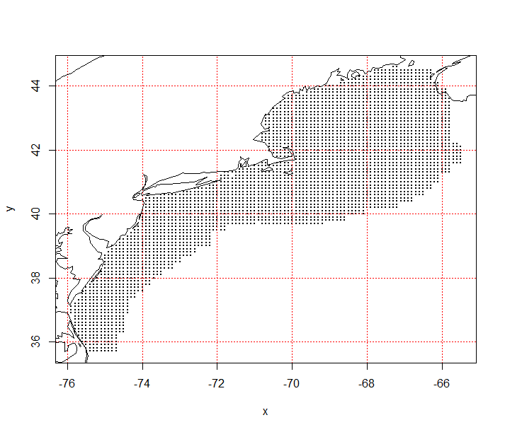

**References**

Belkin, I.M. & O'Reilly, J.E. (2009) An algorithm for oceanic front detection in chlorophyll and SST satellite imagery. *Journal of Marine Systems,* **78,** 319-326.

Desprespatanjo, L.I., Azarovitz, T.R. & Byrne, C.J. (1988) 25 Years of Fish Surveys in the Northwest Atlantic - the Nmfs Northeast Fisheries Centers Bottom Trawl Survey Program. *Marine Fisheries Review,* **50,** 69-71.

Friedman, A., Pizarro, O., Williams, S.B. & Johnson-Roberson, M. (2012) Multi-Scale Measures of Rugosity, Slope and Aspect from Benthic Stereo Image Reconstructions. *Plos One,* **7**.

Grosslein, M.D. (1969) Groundfish Survey Program of BCF Woods Hole. *Commerical Fisheries Review,* **31,** 22-35.

Grover, J.J. (1998) Feeding habits of pelagic summer flounder, Paralichthys dentatus, larvae in oceanic and estuarine habitats. *Fishery Bulletin,* **96,** 248-257.

Hobson, R.D. (1972) Surface roughness in topography: quantitative approach. *Spatial analysis in geomorphology* (ed. R.J. Chorley), pp. 221–245.Harper and Row, New York, New York, USA.

Kane, J. (2007) Zooplankton abundance trends on Georges Bank, 1977-2004. *Ices Journal of Marine Science,* **64,** 909-919.

Kinlan, B.P., Winship, A.J., White, T.P. & Christensen, J. (2016) Modeling At-Sea Occurrence and Abundance of Marine Birds to Support Atlantic Marine Renewable Energy Planning: Phase I Report. U.S. Department of the Interior, Bureau of Ocean Energy Management, Office of Renewable Energy Programs, Sterling, VA. OCS Study BOEM 2016-039. xvii+113 pp.

Lundblad, E., Wright, D.J., Miller, J., Larkin, E.M., Rinehart, R., Anderson, S.M., Battista, T., Naar, D.F. & Donahue, B.T. (2006) A Benthic Terrain Classification Scheme for American Samoa *Marine Geodesy,* **29,** 89-111.

Maritorena, S., d'Andon, O.H.F., Mangin, A. & Siegel, D.A. (2010) Merged satellite ocean color data products using a bio-optical model: Characteristics, benefits and issues. *Remote Sensing of Environment,* **114,** 1791-1804.

Murphy, M.A., Evans, J.S. & Storfer, A. (2010) Quantifying Bufo boreas connectivity in Yellowstone National Park with landscape genetics. *Ecology,* **91,** 252-261.

Riley, S.J., DeGloria, S.D. & Elliot, R. (1999) A terrain ruggedness index that quantifies topographic heterogeneity. *Intermountain Journal of Sciences,* **5**.

Rodionov, S.N. (2004) A sequential algorithm for testing climate regime shifts. *Geophysical Research Letters,* **31,** Doi 10.1029/2004gl019448.

Rodionov, S.N. (2006) Use of prewhitening in climate regime shift detection. *Geophysical Research Letters,* **33,** Doi 10.1029/2006gl025904.

Sappington, J.M., Longshore, K.M. & Thompson, D.B. (2007) Quantifying landscape ruggedness for animal habitat analysis: A case study using bighorn sheep in the Mojave Desert. *Journal of Wildlife Management,* **71,** 1419-1426.

Sherman, K., Solow, A., Jossi, J. & Kane, J. (1998) Biodiversity and abundance of the zooplankton of the Northeast Shelf ecosystem. *Ices Journal of Marine Science,* **55,** 730-738.

Winship, A.J., Kinlan, B.P., White, T.P., Leirness, J.B. & Christensen, J. (2018) Modeling At-Sea Density of Marine Birds to Support Atlantic Marine Renewable Energy Planning: Final Report. U.S. Department of the Interior, Bureau of Ocean Energy Management, Office of Renewable Energy Programs, Sterling, VA. OCS Study BOEM 2018-010. x+67 pp.

Yue, S., Pilon, P., Phinney, B. & Cavadias, G. (2002) The influence of autocorrelation on the ability to detect trend in hydrological series. *Hydrological Processes,* **16,** 1807-1829.